Introduction

Over the past years as the Internet has started making progressive changes for the world, there has been a new crime that occurs digitally that is known as **phishing*.*** A report from *Defending against phishing attacks: taxonomy of methods, current issues and future directions* provides a clear definition, stating that it is a lucrative identity theft crime that uses social-engineering tactics to manipulates victims to give up sensitive details such as bank login credentials and email passwords [1] .The attackers known as phishers would generate fake emails disguising themselves as staff members or a person of authority and urging their victims to click on the clone website that the phishers had designed to trick their victims into entering their personal credentials. A survey by Gartner had shown that approximately 3.6 million clients in the US alone had lost money to phishing attacks and total losses had reached approximately US$ 3.2 billion Dollar. The number of victims increased from 2.3 million in 2006 to 3.6 million in 2007, an increase of 56.5%. Among all complaints received by the Federal Trade Commission in 2009 from Internet users, identity theft attributed to phishing email ranked first. It accounted for 21% of the complaints and cost consumers over 1.7 billion US dollars [2].

This digital crime has only continued growing exponentially and affecting more victims globally. It is essential for Online Users such as ourselves to learn how to protect ourselves from this rampant scam. By doing so, we would require to understand the threat and the solutions to prepare ourselves in the events that we encounter a phishing scam. This report will simulate a phishing attack using **GoPhish** and evaluate the effectiveness of the security tool **ClamAV** in detecting and mitigating these attacks within a **Kali** environment.

Tool Selection

**Attacker tool: GoPhish** is an open-source phishing framework that allows users to create, send, and monitor phishing campaigns. It’s widely used for educational and organizational training purposes to test users’ ability to identify phishing attempts. It provides beneficial features for new phishing users such as a user-friendly interface that provides a web-based dashboard for setting up phishing campaigns, managing targets and tracking results; providing users to design email templates, landing pages and schedule emails and providing detailed analytics like tracking the number of emails that open, clicks and data entered by recipients.

There are other widely known phishing tools such as **PhishSim** and **King Phisher** however GoPhish was the most suitable option as GoPhish is simple and direct to setup on the Linux virtual box compared to PhishSim that requires organization deployment and King Phisher requires server setup on Linux. Besides that, customization on phishing campaigns is simpler compared to PhishSim. In addition, GoPhish is able to scale well for both small and large tests without needing more technical setup unlike King Phisher. Overall, GoPhish is ideal for its ease of use, powerful analytics and open- source accessibility.

**Defender tool: ClamAV** is an open-source antivirus engine designed to detect malware, viruses, and other malicious threats across various platforms, including Windows, Linux and macOS. This tool is used for malware detection as it scans emails for malicious links and phishing URLs based on a defined database that often receives updates regarding new phishing techniques or URLs. It also has scheduled scans available to verify if the user’s device had been infected.

There were other defender tools that are known for fighting phishing attacks such as Microsoft Defender and Proofpoint however ClamAV was the best option as it was a simple setup on the Linux virtual box compared to Microsoft Defender where it is required to have a Windows setup and Proofpoint requires enterprise-level deployment which isn’t convenient for a test setup. Besides that, the user interface is lightweight compared to Microsoft Defender. To summarise the reasoning of choosing this tool, ClamAV is ideal for a lightweight, open-source alternative and able to setup on a Linux platform.

**Virtual Environment: Kali Linux** is the virtual environment where the attacking and defending will take place. Kali Linux is designed for professionals and students in cybersecurity, it provides a robust environment to conduct controlled tests like phishing simulations, malware analysis and network security assessments.

The reason of choosing this virtual box over other alternatives is because kali provides a broad selection of tools that allow users to conduct multiple types of security analyses without needing to add extra utilities. Furthermore, compared to BlackArch, Kali is user-friendly and it is accessible to those newer to cybersecurity without needing effectiveness for more experienced users. Documentation is particularly robust which provides faster troubleshooting and access to resources for both general and complex scenarios. Overall, Kali Linux is an optimal choice for a virtualized environment as it offers an extensive toolkit and an excellent platform for testing phishing and defensive tools like ClamAV within a controlled, security-focused environment.

Testing proposal

Phishing especially attacking workplaces is a major security threat to organizations globally. A usual scenario would be an attacker impersonating an employer and ask employees to verify credentials, change passwords or log into new accounts. These emails are often replicate a professional setting of corporate communications to make it harder for users to detect.

Studies show that phishing scams with workplace themes are among the most effective, as they tap into employee’s natural inclination to comply with workplace directives. To reference *Verizon’s Data Breach Investigations Report*, it highlights that 36% of data breaches involve phishing.

This testing proposal displays a simulation of a phishing attack using GoPhish and assessing the effectiveness of ClamAV as a defence mechanism. The goal is to determine whether ClamAV, a popular open-source antivirus tool, can detect and mitigate phishing URLs or attachments embedded in phishing emails.

**Testing Objectives:** ClamAV’s capabilities will be assessed in detecting phishing content and the limitations of ClamAV detecting zero-day phishing threats will be analysed.

**Metrics for success:** ClamAV is able to scan and detect the email with the malicious link and/or able to analyse zero-day phishing attacks.

Mitre TTPS

The phishing technique spear phishing link (T1566.002)is sending an email with a malicious link is sent to the victim, enticing them to click and enter credentials on a fake website. An email purporting to be from the company’s HR department welcomes the recipient as a new employee and prompts them to click on a link to access their “new work account”. The link directs the victim to a page mimicking an official company login page, capturing credentials upon entry. The defence tool ClamAV would scan incoming emails for known malicious URLs or attachments, although it may struggle with detecting zero-day phishing links.

The next phishing technique is user execution (T1204.001), convincingusers to click on a link in a phishing email that initiates a browser session to a fake website. The email contains a convincing link to what appears to be a work-related portal. Once clicked, the link could download malware or open a page designed to harvest login credentials. Implementing URL filtering, sandboxing, or advanced email filtering on corporate email servers can help detect malicious links before they reach end users.

In this phishing technique credential dumping (T1071.001), an attacker collects entered credentials directly from the phishing site. After clicking the link, users are taken to a fake login page where their work credentials are entered and sent back to the attacker’s server. Endpoint monitoring or security awareness training for employees can reduce phishing attacks.

Testing Scenario

Phase 1: Attacking Phase

**Attacker tool – GoPhish**

**Step 1: Downloading GoPhish on Kali**

GoPhish has to be downloaded in Kali terminal with following command:

“sudo apt install gophish”

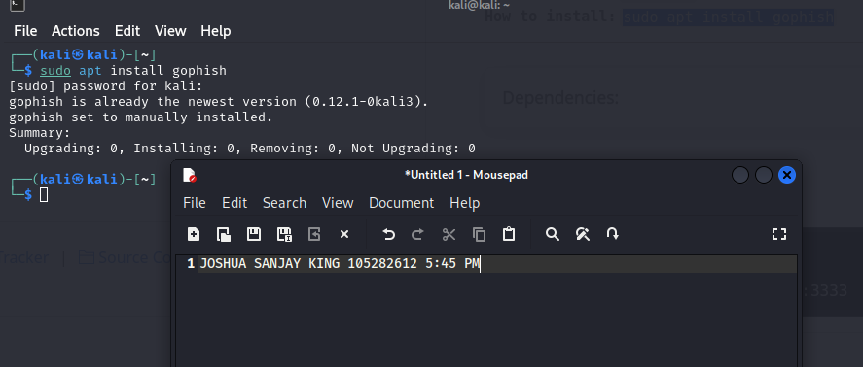

**Step 2: Creating a landing page**

Once setup is complete, it’s time to start creating the webpage where the phishing attacks will take place. GoPhish provides user friendly interface that allows customization processes simple. I have used a general HTML page that request users to enter their username and password.

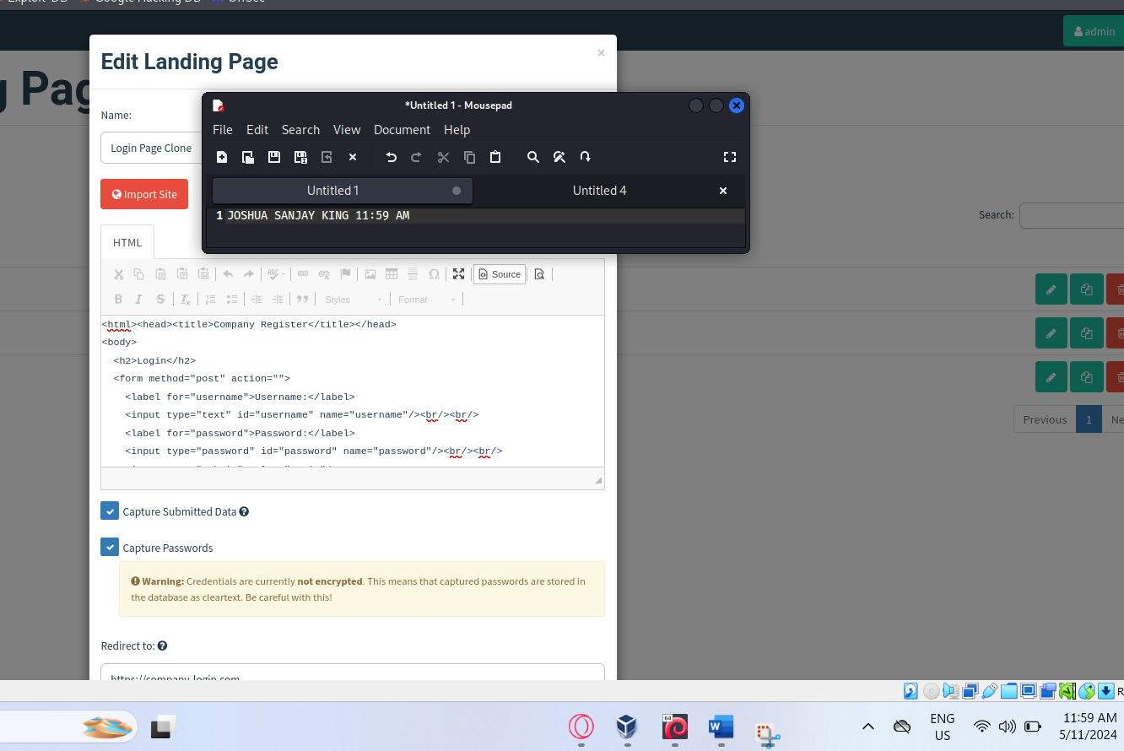

**Step 3: Creating Email template**

Once the landing page is complete, an email template is necessary in order to communicate with the victims. As seen in the screenshot, “{{. FirstName}}”, is a code that will return the first name of the recipient’s email address. This adds a personalised element to the email, enticing receivers to engage with the email rather than a generic message to all. A sense of urgency is also added as the email persuades the recipient to click on the URL for communications within the workplace.

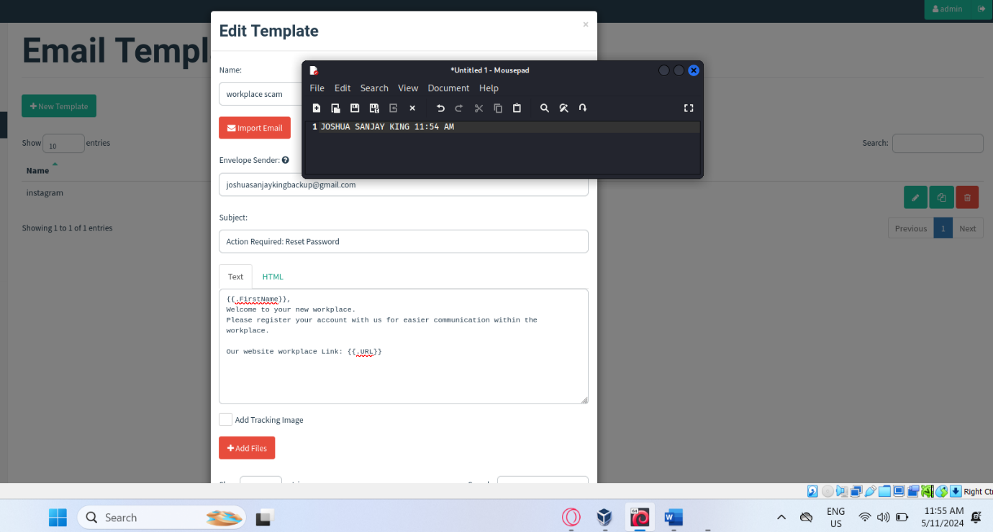

**Step 4: Creating Users & Group**

This step is deciding which recipient would receive the email. GoPhish allows numerous recipients to be added to the list and will send the email to every intended recipient. For testing purposes, we would only focus on sending the phishing email to one recipient with the name “Joe Biden”.

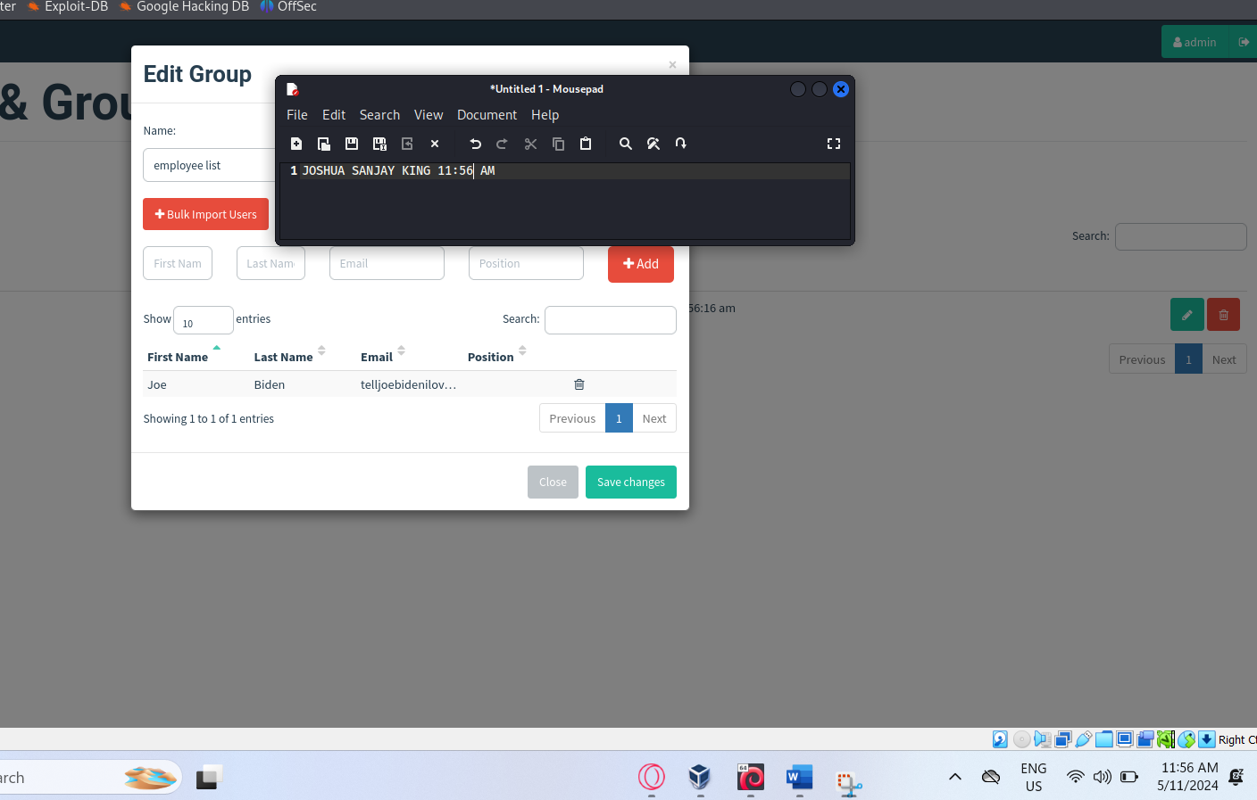

**Step 5: Creating sending profiles**

The purpose of this step is to create a sender profile that the recipient’s would notice. Since our test account “Joe Biden” is using a Gmail account, the sending profile will have to use the same host email server “smtp.gmail.com:587”

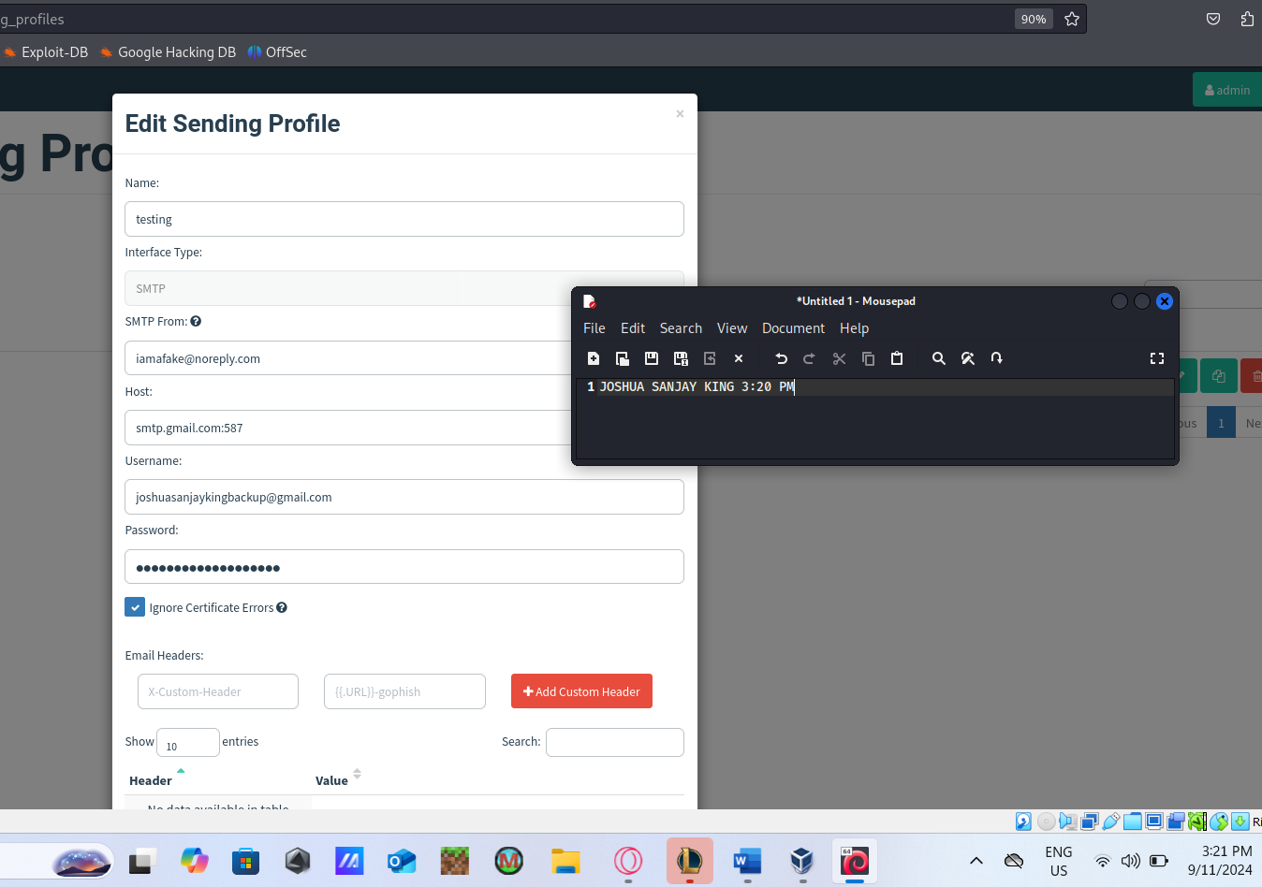

**Step 6: Creating the campaign**

This is the final step for making a phishing campaign. GoPhish provides customization options to change sending profiles and the groups of recipients.

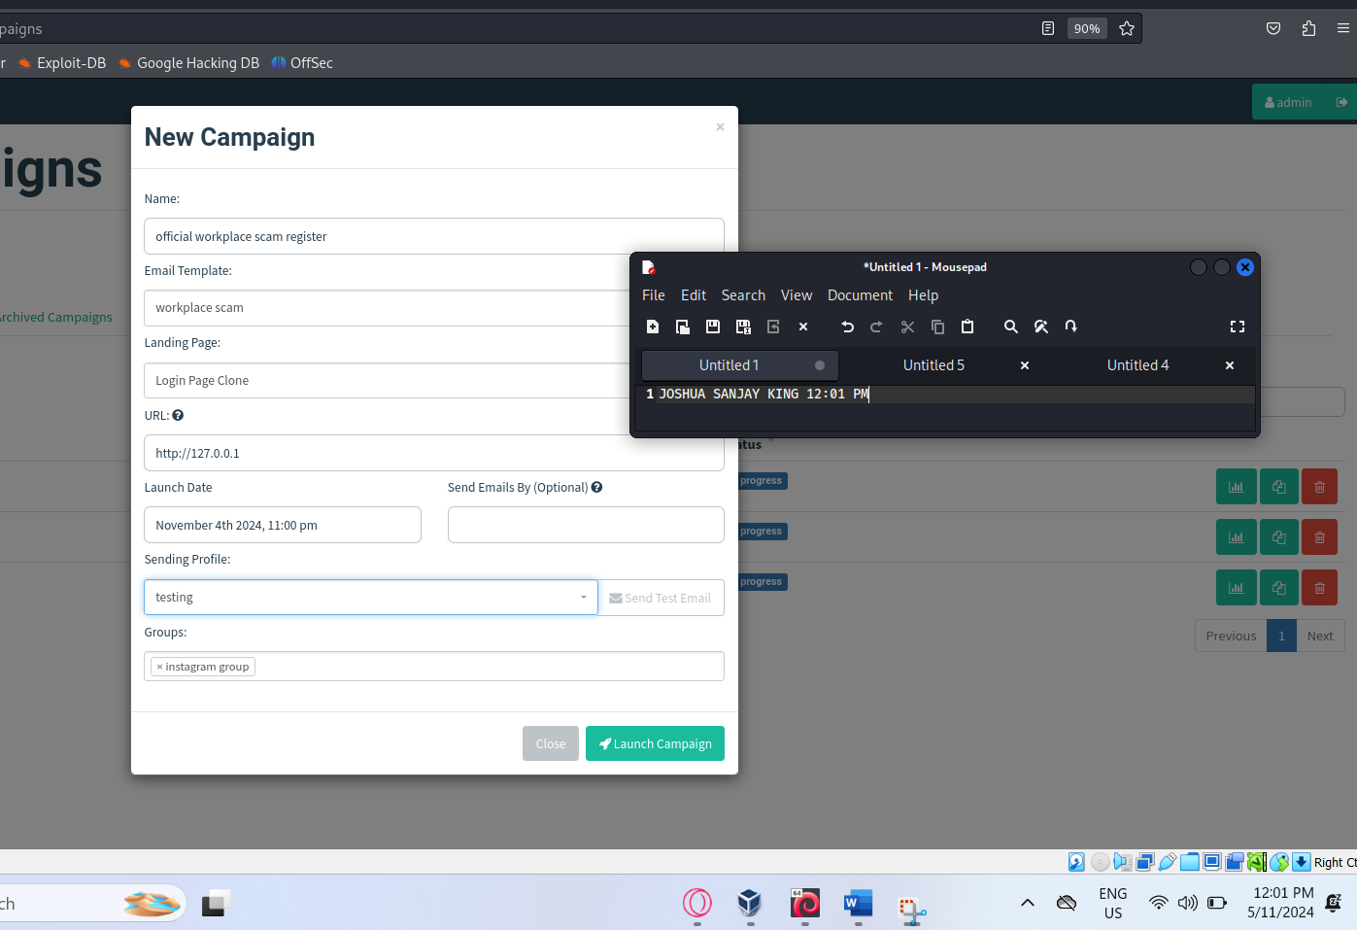

**Results of the Campaign**

**Result 1:** This is the email that victims would receive. Notice that in the starting line is the name of the recipient “Joe”. A working link with a blue underline would entice victims to click on it.

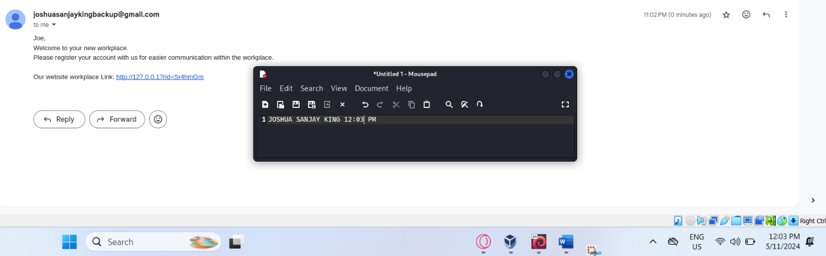

**Result 2:** This is HTML page that users would be led to after clicking. It is a very general login page without nothing else to go on or making new employees think twice before proceeding to enter their credentials.

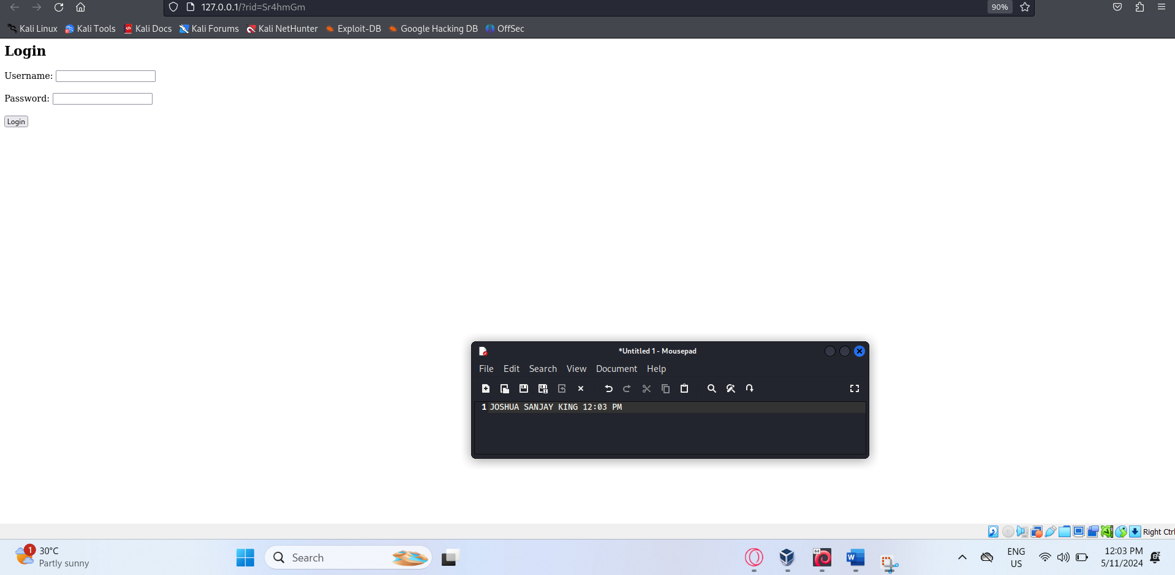

**Result 3:** Once the victims had entered their credentials, the page will go blank and display a message saying the page had been interrupted. The credentials are then sent back to GoPhish website where a detailed report of events such as the time of when the email was sent, when the link was clicked and the victim’s credentials that were stolen.

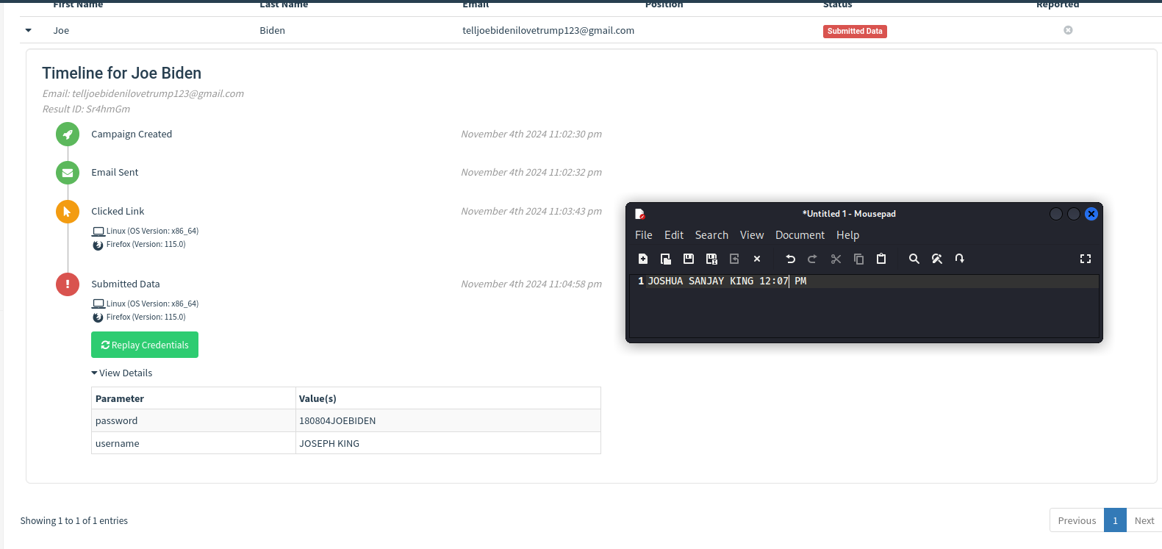

Being able to capture the credentials of the victims concludes the attacking phase and is regarded as a success on behalf of the attacking phase. The following step would be the defence phase.

Phase 2: Defending Phase

**Defending Tool - ClamAV**

**Step 1: Downloading ClamAV**

ClamAV would be downloaded on the Kali Linux with the following command

“sudo apt install clamav”

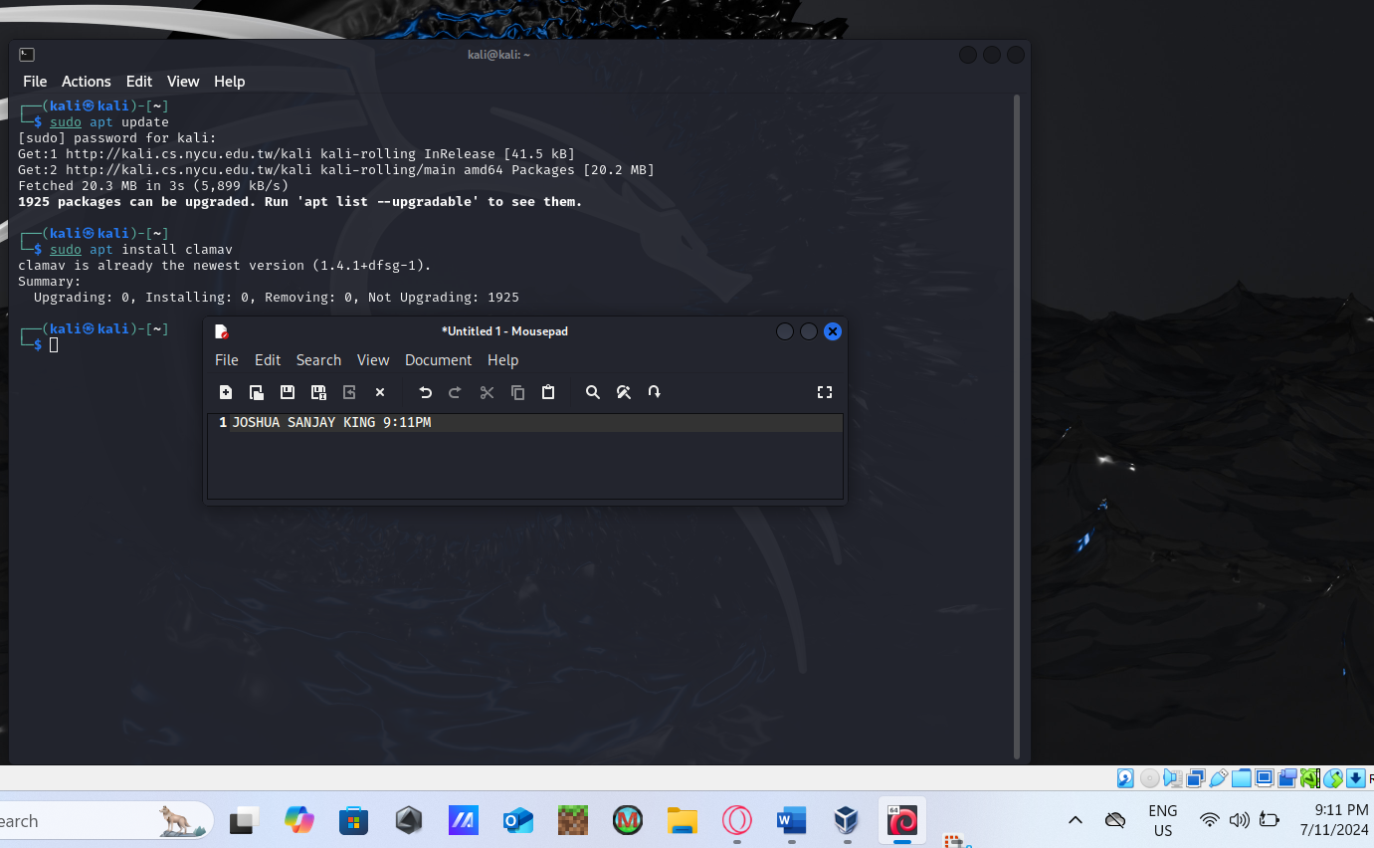

**Step 2: Update the phishing database to the latest version**

Before running a scan, it is important that the database of the defence tool is updated to be able to combat new and existing phishing attacks. The following command downloads the latest definitions, including phishing URLs and common spam signatures:

“sudo freshclam”

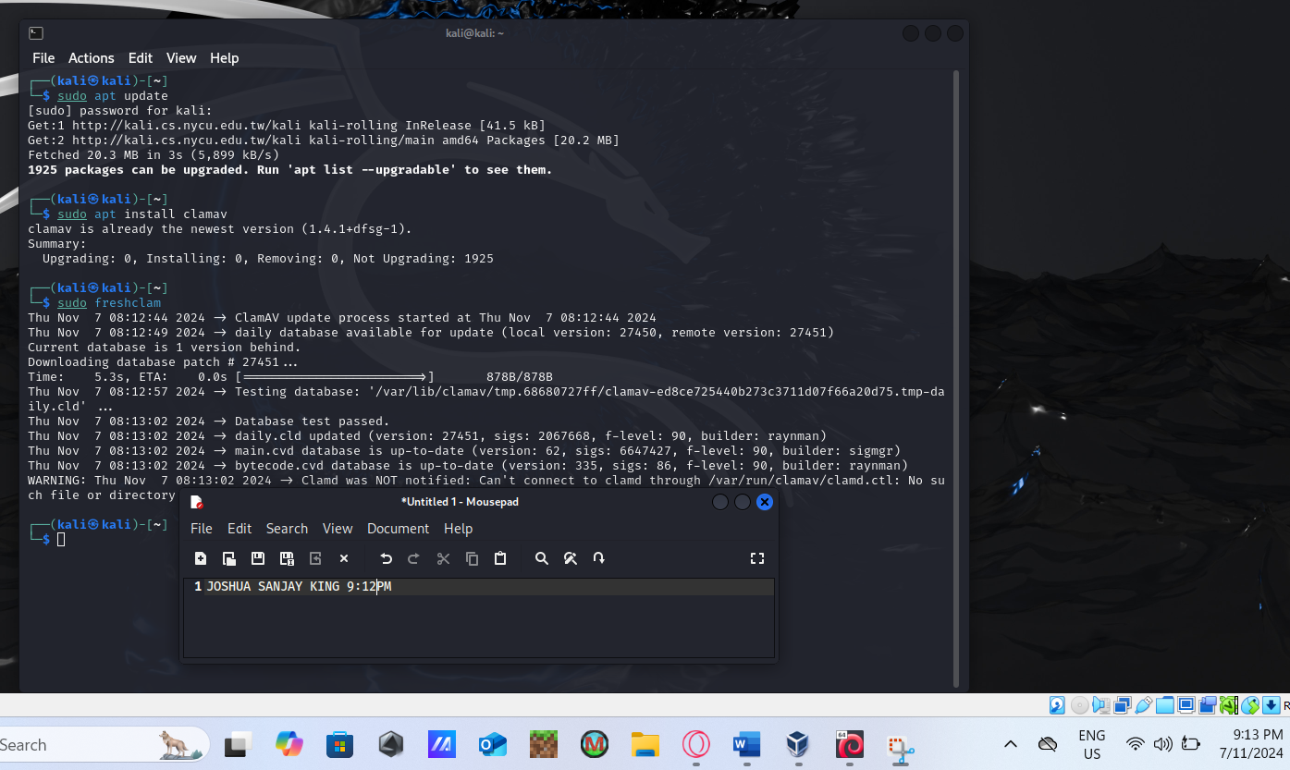

**Step 3: Scan the email file**

Once the tool’s database is updated, the scanning process should be able to be precise and fair. To run the scan, the following command is used:

The general code used is “sudo clamscan -r ~[enter directory path to email file]”

In this case “sudo clamscan -r ~/Desktop/scam”

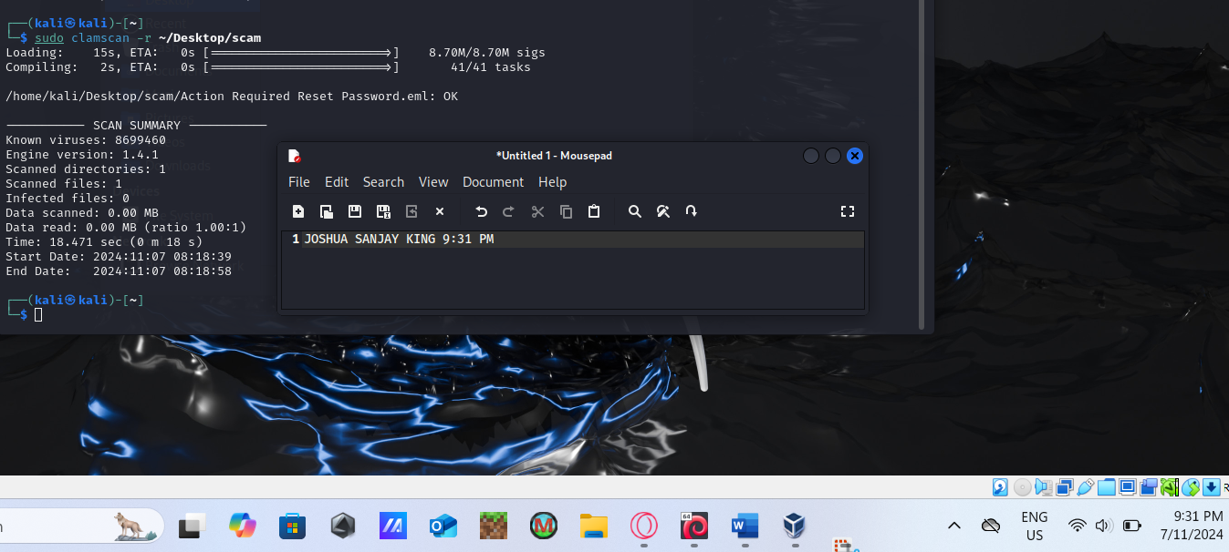

From the scanning report, the defence tool had concluded that file was safe to use, declaring the defending phase a failure.

ClamAV relies on a database that records current existing phishing sites and need continuous updating in order to be effective. However, this reliance would deem the defender tool as ineffective as it won’t be able to detect zero-day phishing attacks. The result of the defender tool had failed according to the given metric as it couldn’t recognize the threat as it hadn’t previously encountered it before. This testing displays that defender tools lacking heuristic or behavioural analysis capabilities are not able to notice any threats if the phishing attack was uniquely crafted or a new link had just been created.

Although the defender tool wasn’t able to detect a zero-day phishing attack, ClamAV had demonstrated good usability and is suitable for environments that prioritize open-source solutions.

In conclusion of this testing, ClamAV is a valuable tool for detecting well-documented malware and popular phishing links, its reliance on signature-based detection makes it insufficient as a stand-alone defence against zero-day phishing threats. In real world scenarios, zero-day phishing attacks are increasingly common as attackers constantly develop new techniques to evade detection.

**Mitigations Of Phishing Attacks**

It is clear that phishing at current times is at a very sophisticated level where many well-known defender tools such as ClamAV not being able detect and prevent victims from proceeding onto the malicious link. The main reason that these kind of defender tools is not able to battle against phishing threats is due to its nature of the attack relying on the vulnerabilities of the human users and not the system vulnerabilities. There are essential mitigation strategies that were provided by the Australian Cyber Security Centre (ACSC), that outline a practical framework for improving resilience against cyber threats.

User awareness remains one of the most effective defences against phishing. Regular training programs that educate employees on identifying phishing attempts help reduce the likelihood of users falling for these schemes. Incorporating phishing simulations allows employees to experience a mock phishing attempt in a safe environment and help them to recognise a phishing tactic.

Many phishing attacks reach their targets through email, making advanced email filtering a vital first line of defence. Implementing filters to detect and block potentially malicious emails before they reach users greatly reduces exposure to phishing threats.

Restricting the execution of unauthorized application, particularly web browsers or email applications, limit opportunities for malware introduced by phishing links to execute. Organisations can create an additional safeguard by allowing only approved applications can reduce the chances of

Regular updating and patching applications minimize vulnerabilities that attackers could exploit through phishing. For example, vulnerabilities in browsers or email clients can provide attackers with entry points through which they can inject malware or exploit unpatched systems.

By disabling risky features in applications (etc. Java, Flash and web ads), user application hardening reduces the likelihood of phishing websites triggering malicious scripts. This also includes disabling macros, which are often exploited through phishing emails with malicious attachments.

Limiting administrative privileges can minimize the impact of phishing attacks. If a user without administrative privileges is compromised, the potential for damage is significantly reduced as attackers would have fewer privileges to access critical systems or data.

Adding Multi-Factor Authentication (MFA) into email servers provides an additional layer of protection as it is an effective barrier that block unauthorized access even if credentials are stolen through a phishing attack

Lastly, regular backups and storing the backups securely helps mitigate the risk of data loss due to phishing attacks that lead to ransomware so that in an event of incident, organisations can restore data and resume operations without needing to pay ransom demands.

**Relevance of the testing scenario to the real world**

Phishing attacks is highly relevant in the current cybersecurity landscape and remain a top attack vector for threats actors globally. This testing was not merely a theoretical but mirrors real-world tactics commonly used to compromise the privacy of individuals and organisations.

The *Verizon Data Breach Investigations Report* has cited that phishing is the primary tactic in data exfiltration and credential theft, with 36% of data breaches involving phishing. This shows that phishing is a key initial access method used by attacker as they masquerade as a trusted contact and exploit the human vulnerability to bypass technical defences, making phishing one of the most successful social engineering techniques.

Phishing attacks are becoming increasingly sophisticated, with attackers making unique zero-day phishing sites to evade traditional signature-based defences like ClamAV. These zero-day phishing often involve newly registered or modified URLs that are not in the security databases allowing these sites to bypass conventional antivirus tools.These sites are often taken down a short period after targeting their users or organisations, making it unable for the security database that records malicious URLs to be updated in real time. This evolving phishing tactic highlights the growing need for advanced detection capabilities such as being able to analyse sites in real time and use behaviour-based tools to identify malicious patterns.

Besides credential theft, phishing attacks can escalate gaining access to their victim’s internal system. Successful phishing attacks often lead to attackers targeting other devices within the network and take advantage of the victim’s privileges and access sensitive areas of the organisation. Confidential data would be exfiltrated, altered or attackers would even establish an access points within the system to revisit the compromised network at a later time.

Devices and networks today are more interconnected than ever, and a single compromised account can be a gateway for a whole network attack, illustrating this how phishing remains a critical issues within the cybersecurity space. There are several ways to address this critical issue which is enforcing a multi-layered defence strategy and also intensive user training to mitigate the ever-evolving tactics of phishing.

In short, phishing is a real-world threat that is continuously evolving and evading most defending tools. It should be noted that although this threat can be difficult to battle against, there are ways to address this critical issue by more adaptive security measures like multi-layered defence and maintaining the security of every organisation data.

**Conclusion**

Phishing is a digital crime that uses social-engineering techniques to steal personal credentials. In order to trick victims, attacker would impersonate as a trustworthy person and give instructions to victims to leak their personal credentials. This report explores the attack through a phishing simulation using GoPhish and evaluates the effectiveness of the defender tool selected, ClamAV, within a Kali Linux environment.

GoPhish was chosen for its simplicity in creating, sending and tracking phishing campaigns. Compared to other tools, it is user-friendly and highly customizable, making it ideal for educational and testing scenarios. ClamAV was selected as the defender tool for its Linux compatibility and capacity to detect phishing-related malware.

The test done for the report simulates a phishing attack, mimicking a workplace-themed email urging recipients to enter credentials on a fake login page. ClamAV’s ability to detect phishing URL embedded in the email was assessed, with success measured by its detection of malicious links or zero-day phishing threats. However, ClamAV could not recognise the file as a threat due the nature of the attack being a zero-day attack, demonstrating a gap in defences against zero-day attacks.

The report had provided various steps that users can take to safeguard their devices. Firstly, user education such as attending training programs and undergoing a phishing simulation is the best line of defence for a phishing attacking. Besides that, additional layers of defence such as advanced email filtering, restricted application execution, application hardening and regular patching can reduce the vulnerabilities of the device system. Lastly, enforcing a multi-factor authentication in email servers and backing data often is a protective measure that can reduce the risk of unauthorised access and data loss.

Zero-day phishing attacks remains a significant issue in the cybersecurity space as there are not many tools that can detect and analyse phishing attempts in real time, highlighting the importance for needing more adaptive and multi-layered security approaches to counter this evolving threat.